# Gyro Sensor

A gyro sensor is a solid-state device that measures *angular velocity*, or in other words, it measures how quickly the device is rotating. By knowing the speed and direction of rotation, it is possible to measure absolute angle change over time, which provides a relative heading. This can be calibrated to read in degrees, similar to a compass.

The accuracy of a gyro sensor varies with temperature and can be influenced by vibrations. When properly calibrated, the gyro can provide a reasonably accurate heading over a short period of time (a few minutes).

**Open up the Serial Monitor.** If you get an error, you probably need to close the Serial Plotter window.

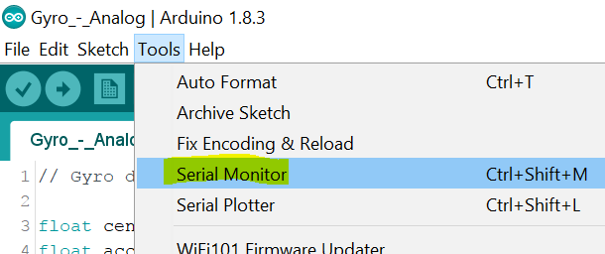

**\*\*\* For this gyro to work properly, be sure to keep the box flat on the table \*\*\***

1. **To calibrate a gyro**, the device must remain stationary so that static readings (ie. 0 rotational velocity) can be measured. While holding the box perfectly still press the button on its top to begin a calibration. This calibration will run for 3 second and then display the calibration factor on the Serial Monitor.

Try a few calibrations to see what values you get. How consistent are they? What happens if you move the gyro during calibration?

1. **The gyro will provide a relative heading.** After calibration, you’ll see the gyro heading (in degrees) streamed to the Serial Monitor.Whichever direction the gyro is facing when calibrated represents the heading of 0. This is unlike a compass, which has an absolute heading of zero when facing North.

The gyro will report degrees of rotation from its starting heading. Try calibrating the gyro at different start positions.

1. **The gyro heading is cumulative.** Try rotating the gyro past 360 degrees. Try it both clockwise and counter-clockwise. Can you unwind it back to zero? Not how well it retains its heading.
2. **The gyro will drift (accumulate error) over time.** Drift should be fairly small if it gets a good calibration (less than a degree or two per minute). Close the Serial Monitor and open up the Serial Plotter to graphically see the drift and overtime. Is the drift erratic or predictable?

